CREATE IBM WATSON IOT PLATFORM AND DEVICE

|  |  |
| --- | --- |
| Date | 22 October 2022 |
| Team ID | PNT2022TMID4963 |
| Project name | Gas leakage monitoring & Alerting System for Industries |

1)

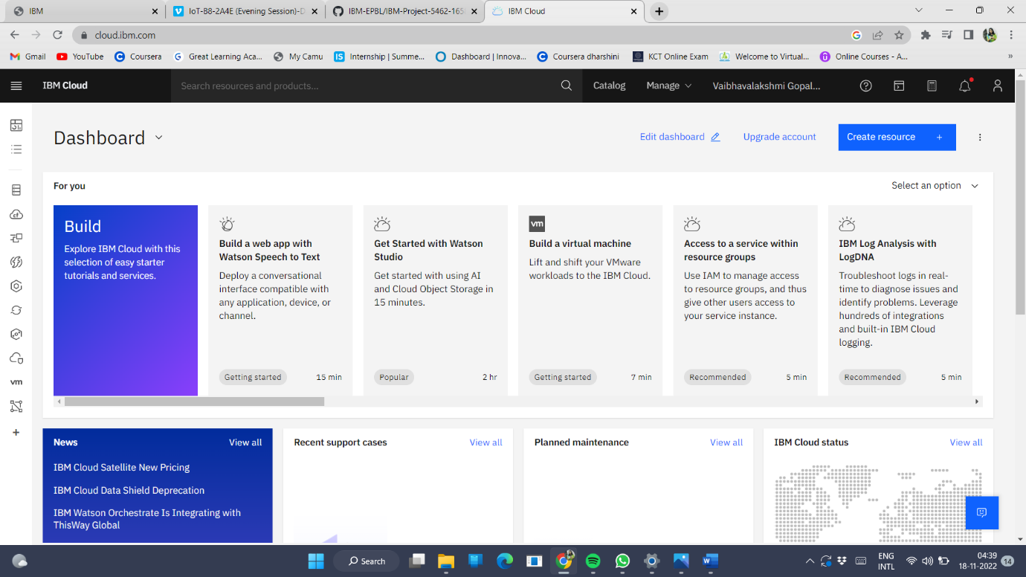

2)

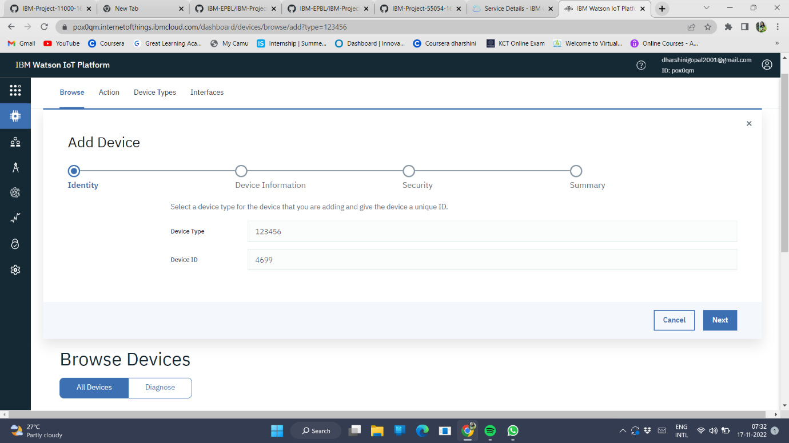

3)

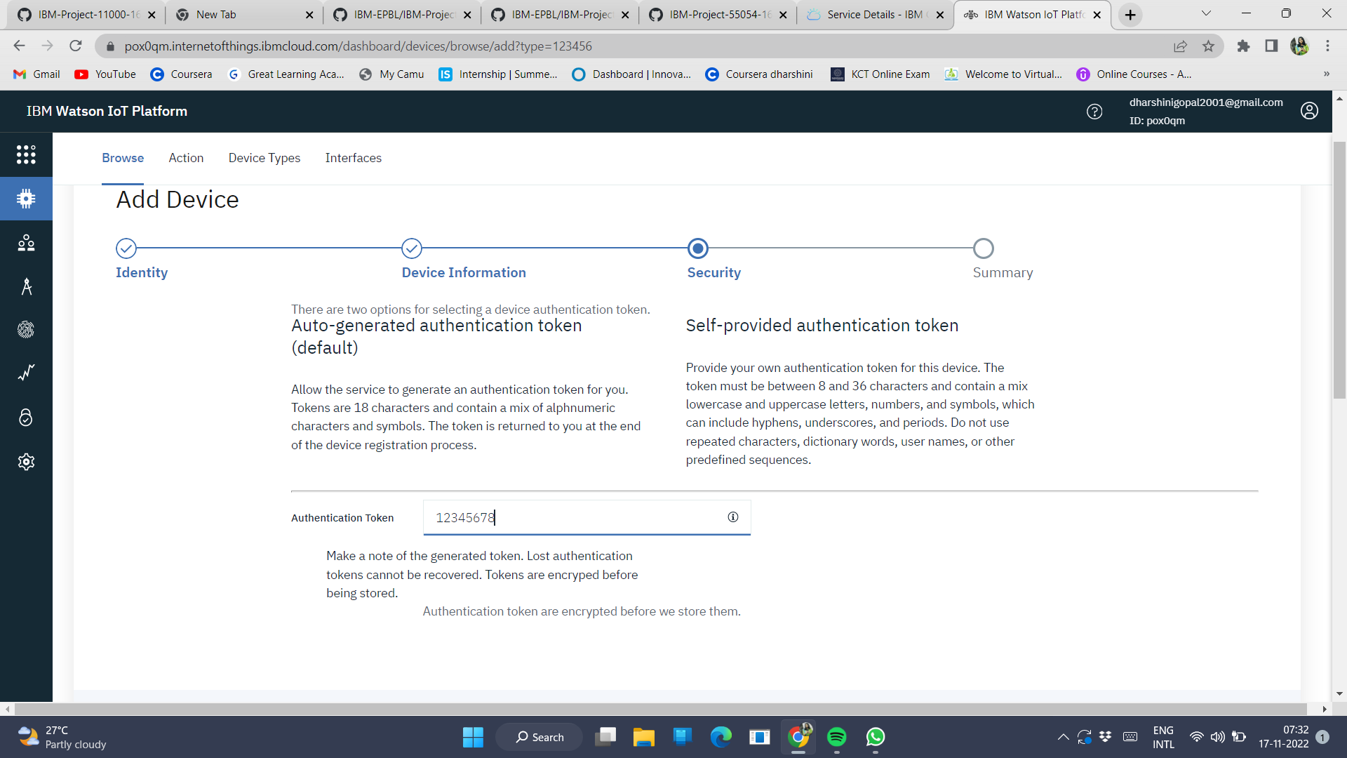

4)

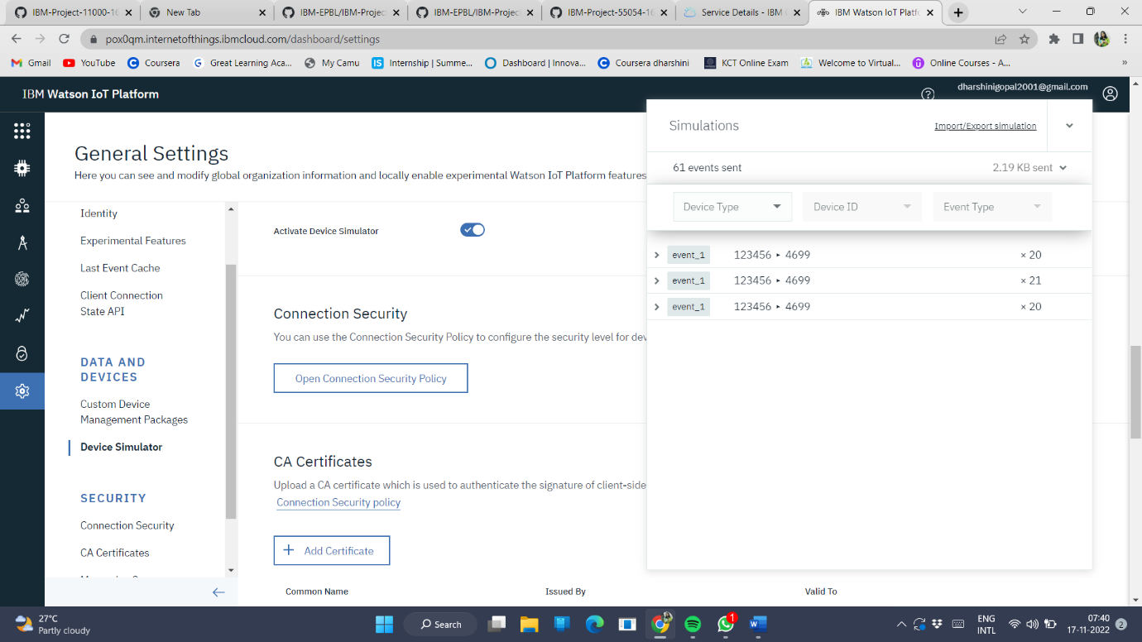

5)

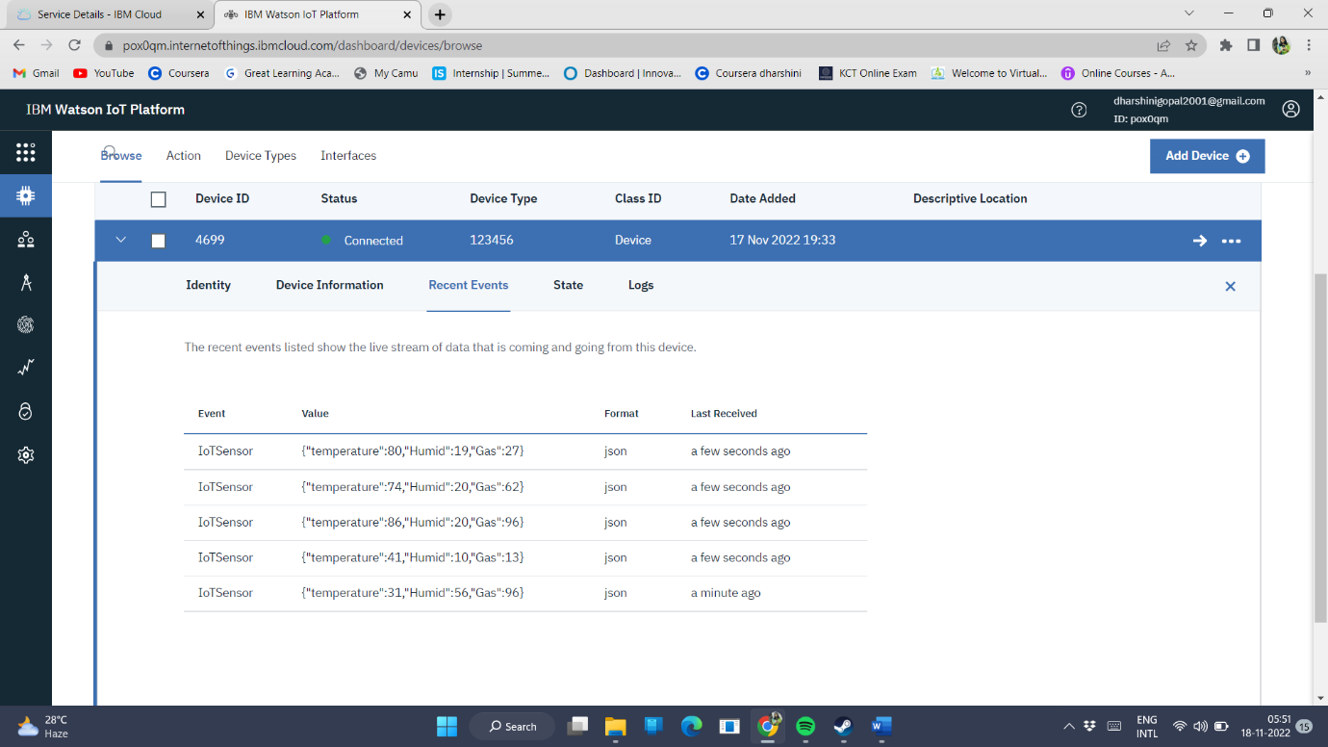

6)